Sunday closest to September 21

Proper 20
Year C
RCL
TRACK 2

The Collect
Grant us, Lord, not to be anxious about earthly things, but to love things heavenly; and even now, while we are placed among things that are passing away, to hold fast to those that shall endure; through Jesus Christ our Lord, who lives and reigns with you and the Holy Spirit, one God, for ever and ever. Amen.
Old Testament
Amos 8:4-7
Hear this, you that trample on the needy, and bring to ruin the poor of the land,
saying, "When will the new moon be over so that we may sell grain;
and the sabbath, so that we may offer wheat for sale?
We will make the ephah small and the shekel great, and practice deceit with false balances,
buying the poor for silver and the needy for a pair of sandals, and selling the sweepings of the wheat."
The Lord has sworn by the pride of Jacob:
Surely I will never forget any of their deeds.

The Psalm
Psalm 113
1 Hallelujah! Give praise, you servants of the Lord; *
praise the Name of the Lord.
2 Let the Name of the Lord be blessed, *
from this time forth for evermore.
3 From the rising of the sun to its going down *
let the Name of the Lord be praised.
4 The Lord is high above all nations, *
and his glory above the heavens.
5 Who is like the Lord our God, who sits enthroned on high *
but stoops to behold the heavens and the earth?
6 He takes up the weak out of the dust *
and lifts up the poor from the ashes.
7 He sets them with the princes, *
with the princes of his people.
8 He makes the woman of a childless house *
to be a joyful mother of children.

The Epistle
1 Timothy 2:1-7
First of all, I urge that supplications, prayers, intercessions, and thanksgivings be made for everyone, for kings and all who are in high positions, so that we may lead a quiet and peaceable life in all godliness and dignity. This is right and is acceptable in the sight of God our Savior, who desires everyone to be saved and to come to the knowledge of the truth. For
there is one God; there is also one mediator between God and humankind,
Christ Jesus, himself human, who gave himself a ransom for all
-- this was attested at the right time. For this I was appointed a herald and an apostle (I am telling the truth, I am not lying), a teacher of the Gentiles in faith and truth.
The Gospel
Luke 16:1-13
Jesus said to the disciples, "There was a rich man who had a manager, and charges were brought to him that this man was squandering his property. So he summoned him and said to him, `What is this that I hear about you? Give me an accounting of your management, because you cannot be my manager any longer.' Then the manager said to himself, `What will I do, now that my master is taking the position away from me? I am not strong enough to dig, and I am ashamed to beg. I have decided what to do so that, when I am dismissed as manager, people may welcome me into their homes.' So, summoning his master's debtors one by one, he asked the first, `How much do you owe my master?' He answered, `A hundred jugs of olive oil.' He said to him, `Take your bill, sit down quickly, and make it fifty.' Then he asked another, `And how much do you owe?' He replied, `A hundred containers of wheat.' He said to him, `Take your bill and make it eighty.' And his master commended the dishonest manager because he had acted shrewdly; for the children of this age are more shrewd in dealing with their own generation than are the children of light. And I tell you, make friends for yourselves by means of dishonest wealth so that when it is gone, they may welcome you into the eternal homes.
"Whoever is faithful in a very little is faithful also in much; and whoever is dishonest in a very little is dishonest also in much. If then you have not been faithful with the dishonest wealth, who will entrust to you the true riches? And if you have not been faithful with what belongs to another, who will give you what is your own? No slave can serve two masters; for a slave will either hate the one and love the other, or be devoted to the one and despise the other. You cannot serve God and wealth."
SERMON
Most commentaries about today’s gospel pretty much say the same thing--this parable is very difficult to understand!

It doesn’t make sense. A man cheats on his boss and is then praised for doing so? That doesn’t sound right. That’s not what we teach our kids. That’s not what we expect Jesus to say or encourage.

But the gospel ends with this message from Jesus: “No slave can serve two masters; for a slave will either hate the one and love the other, or be devoted to the one and despise the other. You cannot serve God and wealth."

I just read an article about how much it would cost for a family of four to live a ‘modest yet adequate standard of living” in Hawaii, $10,000.00 a month! Out of reach of many.
So, unless we are the rich person, we all are probably slaves to money. We’ve probably all struggled or are struggling with debt. And it’s very stressful.

While I was a teacher for the DOE, I always worked two jobs. And it was very common for teachers. I wasn’t the only one.

We don’t like to talk about money with others, and yet most people I know -- including myself -- struggle with questions about money: how much is enough, how much should we give away, how can we raise children who are both wise and generous. While I'm not sure this parable gives clear guidance to any of these questions, it shows us that people have always been struggling with money, even back then.

So again, Jesus tells us that you “cannot serve God and wealth.”

We easily forget about serving God when we see our neighbor with a new car and think, they seem happy, maybe it’s the car.

We forget about serving God when we buy clothes we don’t need, which sit in our closets untouched, or we buy new gadgets that we used maybe once or twice, but now sit on a shelf, with all the other unused gadgets.

We forget about serving God when we keep our money to ourselves, for ourselves only, instead of giving it away to others that might need it.

We forget about serving God when our debt is out of control and we’re spending all our time working to pay off what we owe.

I remember one year we owed a huge amount of taxes to the IRS. Doesn’t just hearing the words “owe” and “IRS” in one sentence already give you stress?
It’s easy to get angry, “why do I work just to pay taxes?” and then rebellious, “I’ll just pay it late,” and then nervous, “but what if they charge double the amount in interest and arrest me and put me in jail?” and then resigned, “okay, I can only pay a little by little.”

And then we stop and remember that this was not really ours to begin with. And then we live frugally, and we stop obsessing about it and somehow it works out, and it isn’t too painful. We left our fear and anger with God. We moved on.

“Give me an accounting of your management.”

In a way, this tax situation became a wake-up call. It made us look at what our accounting was like. Were we just spending money for ourselves and not spending anything on God?

So soon our check register had more entries of checks made payable to churches, and less entries of debits to Starbucks.

We need to remember that our accounting is not only financial. If we open the books of our lives, what are we doing with the resources and gifts that are being entrusted to us? What are we doing with our time, ideas, dreams, hopes, passions, concerns, abilities, and talents? With people and relationships? What are we doing about love, forgiveness, compassion, and mercy? Where, how and in what ways are we spending our assets?

I have a friend who believes that if she gives her money away, she will get it back twofold. And by getting it back, she doesn’t mean doubling her income. What she gets back is the satisfaction of knowing that she helped someone when they needed help the most. She gets back new friends, and sometimes old friends who she lost along the way.

But the money doesn’t matter to her. What matters is her love for Jesus. And by generously sharing what she has, she is also sharing God’s grace and love. She has found her purpose in life.

We too, can find our purpose by using our money wisely to build up the Kingdom of God.

For “No slave can serve two masters.”

E pule kākou, let us pray.
Direct us, O Lord, in all our doings with thy most gracious
favor, and further us with thy continual help; that in all our
works begun, continued, and ended in thee, we may glorify
thy holy Name, and finally, by thy mercy, obtain everlasting
life; through Jesus Christ our Lord. Amen.

Amen.
Prayers:
Fr. Hee (travels)

We pray for the Nishihiras who lost their mom/grandma on Thursday evening. Almighty God, Father of mercies and giver of comfort: Deal
graciously, we pray, with all who mourn; that, casting all
their care on you, they may know the consolation of your
love; through Jesus Christ our Lord. Amen.

We pray for All Saint’s Kapa’a members, Suzanne Kobayashi and Mary Margaret, who are seeking ordination.

We pray for Kathy Long, complications with a bone marrow transplant.

Announcements:

I connected with Jay Nishimura, Activities Manager at Palolo Chinese Home. They would love to have holiday table decorations and greeting cards. See me if you’d like to participate!

The Annual Convention is coming up on October 22nd and our delegates are Faith, Deb, and Betsy.

Lokahi Na Wahine, which is the Women’s Support Group has been meeting on Fridays and now Saturdays. Come to this non-judgmental, free group.

This evening I’m on my way to Minnesota for the EAM conference for a week and a half. Fr. Greg will be here next Sunday. See you all when I get back!

Vicar’s Message:
Back in 2010, Good Sam sent me as their representative to an Episcopal Asiamerica Ministry (EAM) meeting on the mainland and I have been actively involved ever since. In fact, this afternoon I’m headed to the EAM gathering in Minnesota. We will be honoring Fr. Fred Vergara who will be retiring as the Asian Missioner after many years. The Japanese Convocation (JCON), which Good Sam belongs to, will be meeting along with the Chinese, Korean, Filipino, Southeast Asian, and South Asian convocations. We will be setting JCON’s visit to New York next year! Blessings to you and I’ll see you when I return.

Announcements:

New House of Deputies President
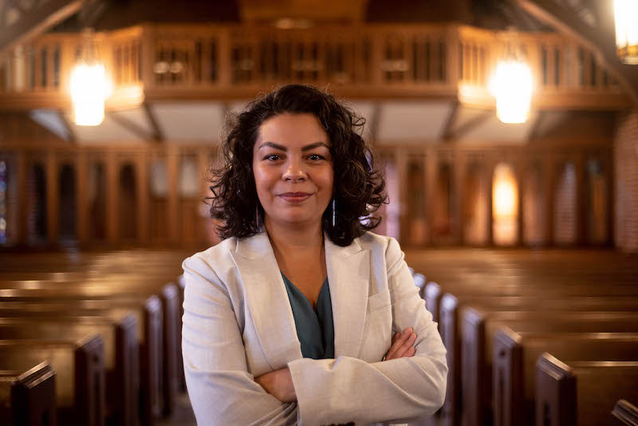
Julia Ayala Harris is the first woman of color to serve as President of the House of Deputies for the General Convention. At age 41, she is the youngest to serve in recent memory. Welcome to Julia!

Pet Blessing
Daisy pic | Kip pic | Hata pup pic
Kimi Lee | Ke’a Magno | Chocolate Hee
Taylor’s dogs | Lapa Magno | Other pets?

We remember our pets in honor of the Patron Saint of Animals, Saint Francis of Assisi. There will be a special pet blessing during the service on Sunday, October 2nd! Bring your pet or bring a photo to receive prayers from Fr. Hee.

Recipe Corner
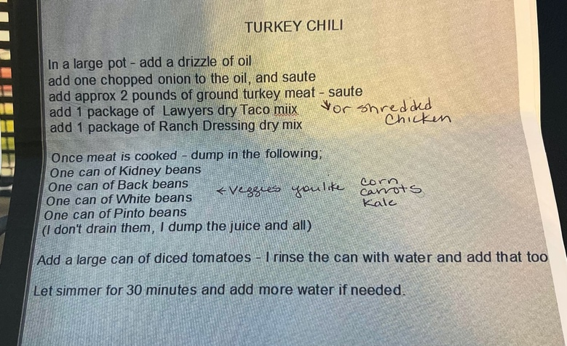
Chris Omuro shares her delicious chili recipe we had last week!

