Fifth Sunday after Epiphany

Year A
RCL

The Collect
Set us free, O God, from the bondage of our sins, and give us the liberty of that abundant life which you have made known to us in your Son our Savior Jesus Christ; who lives and reigns with you, in the unity of the Holy Spirit, one God, now and for ever. Amen.

Old Testament

Isaiah 58:1-9a
Shout out, do not hold back!
Lift up your voice like a trumpet!
Announce to my people their rebellion,
to the house of Jacob their sins.
Yet day after day they seek me
and delight to know my ways,
as if they were a nation that practiced righteousness
and did not forsake the ordinance of their God;
they ask of me righteous judgments,
they delight to draw near to God.
“Why do we fast, but you do not see?
Why humble ourselves, but you do not notice?”
Look, you serve your own interest on your fast day,
and oppress all your workers.
Look, you fast only to quarrel and to fight
and to strike with a wicked fist.
Such fasting as you do today
will not make your voice heard on high.
Is such the fast that I choose,
a day to humble oneself?
Is it to bow down the head like a bulrush,
and to lie in sackcloth and ashes?
Will you call this a fast,
a day acceptable to the Lord?

Is not this the fast that I choose:
to loose the bonds of injustice,
to undo the thongs of the yoke,
to let the oppressed go free,
and to break every yoke?
Is it not to share your bread with the hungry,
and bring the homeless poor into your house;
when you see the naked, to cover them,
and not to hide yourself from your own kin?
Then your light shall break forth like the dawn,
and your healing shall spring up quickly;
your vindicator shall go before you,
the glory of the Lord shall be your rear guard.
Then you shall call, and the Lord will answer;
you shall cry for help, and he will say, Here I am.

The Psalm

Psalm 112:1-9,
1 Hallelujah!
Happy are they who fear the Lord *
and have great delight in his commandments!
2 Their descendants will be mighty in the land; *
the generation of the upright will be blessed.
3 Wealth and riches will be in their house, *
and their righteousness will last for ever.
4 Light shines in the darkness for the upright; *
the righteous are merciful and full of compassion.
5 It is good for them to be generous in lending *
and to manage their affairs with justice.
6 For they will never be shaken; *
the righteous will be kept in everlasting remembrance.
7 They will not be afraid of any evil rumors; *
their heart is right;
they put their trust in the Lord.
8 Their heart is established and will not shrink, *
until they see their desire upon their enemies.
9 They have given freely to the poor, *
and their righteousness stands fast for ever;
they will hold up their head with honor.

The Epistle

1 Corinthians 2:1-12,
When I came to you, brothers and sisters, I did not come proclaiming the mystery of God to you in lofty words or wisdom. For I decided to know nothing among you except Jesus Christ, and him crucified. And I came to you in weakness and in fear and in much trembling. My speech and my proclamation were not with plausible words of wisdom, but with a demonstration of the Spirit and of power, so that your faith might rest not on human wisdom but on the power of God.
Yet among the mature we do speak wisdom, though it is not a wisdom of this age or of the rulers of this age, who are doomed to perish. But we speak God’s wisdom, secret and hidden, which God decreed before the ages for our glory. None of the rulers of this age understood this; for if they had, they would not have crucified the Lord of glory. But, as it is written,
“What no eye has seen, nor ear heard,
nor the human heart conceived,
what God has prepared for those who love him”—
these things God has revealed to us through the Spirit; for the Spirit searches everything, even the depths of God. For what human being knows what is truly human except the human spirit that is within? So also no one comprehends what is truly God’s except the Spirit of God. Now we have received not the spirit of the world, but the Spirit that is from God, so that we may understand the gifts bestowed on us by God.

The Gospel

Matthew 5:13-20
Jesus said, “You are the salt of the earth; but if salt has lost its taste, how can its saltiness be restored? It is no longer good for anything, but is thrown out and trampled under foot.
“You are the light of the world. A city built on a hill cannot be hid. No one after lighting a lamp puts it under the bushel basket, but on the lampstand, and it gives light to all in the house. In the same way, let your light shine before others, so that they may see your good works and give glory to your Father in heaven.
“Do not think that I have come to abolish the law or the prophets; I have come not to abolish but to fulfill. For truly I tell you, until heaven and earth pass away, not one letter, not one stroke of a letter, will pass from the law until all is accomplished. Therefore, whoever breaks one of the least of these commandments, and teaches others to do the same, will be called least in the kingdom of heaven; but whoever does them and teaches them will be called great in the kingdom of heaven. For I tell you, unless your righteousness exceeds that of the scribes and Pharisees, you will never enter the kingdom of heaven.”
The Gospel of the Lord

SERMON

I’m not sure if you know, but I have tattoos on my arms. On one side I have a honu, or turtle design, on my other, I have a band that wraps around my arm.

Since I had them done when I was working as a teacher, I made sure that my shirt sleeves could always cover the design when I was in the classroom.

I never thought any of my preschoolers would notice. But one little boy did. And the next day, his dad came to talk to me before school started.

He said he came home from work yesterday and his son was sitting in the living room. He noticed that he had a black Sharpie marker in his hand and was drawing something on this arm.

When he asked him what he was doing, he said he was making a design on his arm like Mr. Hee’s! Luckily for me, the dad thought this was funny.

But it made me realize that whether we know it or not, we all have an influence on others. And as Christians, we all hope and pray that we are good influencers, not bad influencers, on our family, our friends, and basically, everyone we meet in our lives.

“You are the salt of the earth.” With these words to his disciples, and to us, Jesus is expecting us to do great things in the name of God and God’s Kingdom. We are like salt, essential to life, essential to God.

In Hawaii, we all know how important salt is in our culture. The Hawaiian word for salt is pa’akai. Pa’a means solid and kai means seawater. From the beginning, it preserved our food on long ocean voyages. It was used to cleanse the soul, to heal the body and purify the spirit.
We can see it on our skin after we swim in the ocean, we can smell and taste its saltiness when we stand on a sandy beach. It is in our memories, in our history.

And hearing Jesus proclaim that we “are the salt of the earth” is an affirmation, a blessing, that everything that we know, and feel, and love about God is true and good.

Then Jesus tells us, “You are the light of the world.” and suddenly this feels like a big responsibility. Imagine light in first century Palestine.

We take for granted that we can turn on lights in our homes with the flip of a switch, or that at night our streets are lit by streetlamps.

It wasn’t like that when Jesus lived. Lights and lamps were precious. So, for Jesus to tell us that we are light, from the place and time and world that he lived in, that really meant something.
Jesus is saying that we too, are precious. And although there so many times when we want to be hiding under the bushel basket, safe, away from the coronavirus, away from hurt, pain, or feeling small and insignificant, remember Jesus tells us that like the tiniest lamp, we can all shine brightly! So, don’t be afraid. Don’t be embarrassed. Go out and show the world what a disciple of Jesus looks like!

“Let your light shine before others, so that they may see your good works and give glory to your Father in heaven.

Jesus calls us salt and light. He expects much from us because he promises us more.

He calls us to make a difference in the world, to reconcile, not divide.
To listen to voices that might not sound like ours, to accept those that don’t look like us, to care for those who cannot care for themselves, to be kind to one another, and to share only the best part of us.

And to love. Because we are loved.

You are the light of the world.

Go out and let your light shine!

E pule kākou, let us pray.
O God, by whom the meek are guided in judgment, and
light riseth up in darkness for the godly: Grant us, in all
our doubts and uncertainties, the grace to ask what thou
wouldest have us to do, that the Spirit of wisdom may save
us from all false choices, and that in thy light we may see
light, and in thy straight path may not stumble; through
Jesus Christ our Lord.
Amen.

Prayers
We pray for Kamu Magno who is feeling under the weather, and for Leohone who is caring for him.

We pray for Val Pursel who is healing from her pelvis fracture.

We pray for the birthdays this week:
O God, our times are in your hand: Look with favor, we
pray, on your servants Ariel, James, Kenneth,
Rodney, & Donna.. as they begin another year. Grant
that they may grow in wisdom and grace, and strengthen their
trust in your goodness all the days of their lives; through Jesus
Christ our Lord. Amen.

Announcements
Faye and I are in the Diocesan Cycle of Prayer, thank you for praying for us!

We had Derrick Shimabukuro’s brother’s funeral and burial this past Friday. In getting to know the extended family 7 members want to be baptized at Good Sam on Easter!

It’s Mahina o ka ‘ōlelo Hawaii, or Hawaiian language month. Did you know our official state languages are English and Olelo? If you go to Zippy’s you can also ask for the menu in Hawaiian! Please join us in the pavilion for Hawaiian language classes, everyone is welcome.

Upcoming Events
Saturday, February 18 Altar Guild luncheon
Sunday, February 26 Bishop’s Committee meeting

Vicar’s Message
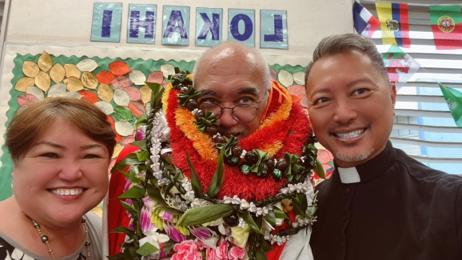
Welcome to The Rev Hau’oli Tomoso, installed by Bishop Fitzpatrick as the new Vicar of Trinity Episcopal Church by the Sea in Kihei, Maui. Faye and I joined him in this momentous occasion. Due to the flooding the event was moved to nearby Kihei Elementary in the cafeteria. Many were present, clergy, The Royal Order of Kamehameha (which Hau’oli is a part of), church members, and family. E ho’omaika’i kākou, let us celebrate!
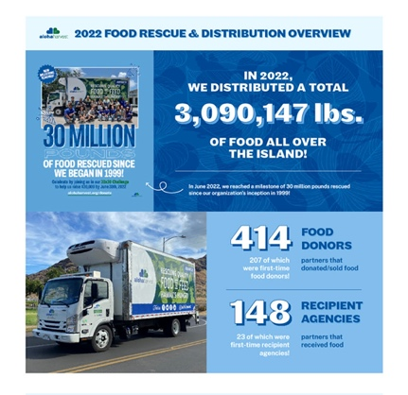
We contributed to the food donation last year at Aloha Harvest!

