GOOD SAMARITAN
EPISCOPAL CHURCH
1801 Tenth Avenue | Honolulu, HI 96816
(808) 735-5944 | E-mail: goodsamhawaii@yahoo.com

November 5, 2023

Dear Members and Supporters of Good Samaritan Church,

Giving is an important element of our spiritual relationship with God. Stewardship is about helping God’s people grow in their relationship with Jesus using the time, talents, and finances that God has entrusted to them. It is a way of life. It is about how God is calling us to respond to God's presence in our lives. As we start a new church year and come upon our Annual Meeting in January, please consider your pledge to Good Sam. Mahalo nui loa to you and thanks be to God!

Testimonial:  Unlike larger congregations who are quite often heavily endowed, our tiny little church is dependent not only on our support in weekly attendance complete with delightful culinary offerings, but also our monetary support in our giving towards its operational expenses and outreach projects.  We have the most wonderful and happy mix of congregants/ “congre-canines” at Good Samaritan Episcopal Church and we need to ensure our church’s continued ministry by being faithful stewards. ~ Kamu and Leohone Magno | 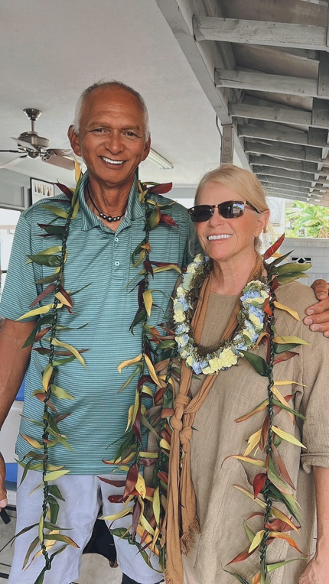

GOOD SAMARITAN EPISCOPAL CHURCH
1801 10th Avenue, Honolulu, Hawaii 96816

Proposed Budget 2024

Item | 2023 Amount | 2024 Proposed | Comments
Income

Pledges/Plate | $88,300 | $97,200 | 10% increase
Interest/Investments | $2,230 | $5,800 | New 4.55% CD
Rent (Including Utilities) | $55,350 | $63,920 | Increase in Vicar’s plus utilities
Fundraises | $4,400 | $5,000
Other | $1,900 | $10.000 | Building use, Hospitality
Total | $152.180 | $181,900
Expenses

Clergy Salary/Allowances/Pension | $48,400 | $77,838 | Increase to ¾ time
Other Salaries  (Organist, Lay Salaries, Supply clergy) | $17,330 | $17,500
Diocesan Assessment | $19,114 | $19,200
Insurance | $12,614 | $14,000 | Anticipate 10% increase
Taxes | $5,340 | $8,800 | Anticipate increase in excise tax
Admin | $2.200 | $2,200
Utilities | $24,200 | $20,090 | Includes new Solar Panels
Building Maintenance | $6,200 | $5,400
Grounds Maintenance | $10,200 | $6,000
Capital Improvement | $2,000 | $10,000
Total | $156,490 | $181,838
 |  | +$62.00

PLEDGE FORM

Good Samaritan Episcopal Church  1801 Tenth Avenue  Honolulu, HI 96816  Phone/Fax (808) 735-5944  Email: goodsamhawaii@yahoo.com | Diocese of Hawaii  Bishop: The Rt. Rev. Robert L. Fitzpatrick  Vicar: The Rev. Dr. Malcolm Keleawe Hee  Bishop's Warden: Betsy Hata  Treasurer: Paul Jackson

Name(s): _________________________________ __________________________________
Address: ____________________________ City: _____________ State:______ Zip:________
Phone: __________________________________ Email: _______________________________
In thanksgiving for God’s gifts of life and community here at Good Samaritan Episcopal Church,
I (we) would like to pledge (choose one of the following):
$ ____________ per week x 52 = $ ____________
$ ____________ per month x 12 = $ ____________
$ ____________ per year x 1 = $ ____________
Total pledge for the year 2024: $ ____________
I (we) understand that as circumstances change and a change in the pledge is needed; I (we) will inform the church Treasurer, so adjustments may be made to my pledge.
Signature(s): _______________________________ __________________________________
We want to pray for you on your birthday and send you a card. Please fill in the following:
Birthday month: _____________ day: _____ name: ___________________________________
Birthday month: _____________ day: _____ name: ___________________________________
Mahalo nui loa for your commitment to Good Samaritan Episcopal Church. Please return this by mail or during the offering, by December 31, 2023.
Almighty God, whose loving hand hath given us all that we possess: Grant us grace that we may honor thee with our substance, and, remembering the account which we must one day give, may be faithful stewards of thy bounty, through Jesus Christ our Lord. Amen.

~ Blessings to you and your family ~

